Calculate DB Szie Growth Rates - SQL Server (Author: SANJAY HUMANIA)
https://www.ourtechideas.com/blog/db-growth/

Introduction
- To calculate DB size ‘Growth Rates‘ on a daily basis in SQL Server we need to track database size changes every day.
- The best solution is to check the database size daily and compare with previous data.
- We may setup a job in SQL Server and gather the information daily.

Create a database
Use below TSQL script or SSMS and create a database ‘REPORT_DB’ to store daily tracked database growth data.
USE master ;
GO
CREATE DATABASE REPORT_DB
ON
( NAME = REPORT_DB_data,
FILENAME = 'C:\Program Files\Microsoft SQL Server\MSSQL13.MSSQLSERVER\MSSQL\DATA\REPORT_DB_data.mdf', -- location
SIZE = 10,
MAXSIZE = 50,
FILEGROWTH = 5 )
LOG ON
( NAME = REPORT_DB_log,
FILENAME = 'C:\Program Files\Microsoft SQL Server\MSSQL13.MSSQLSERVER\MSSQL\DATA\REPORT_DB_log.ldf', -- Location
SIZE = 5MB,
MAXSIZE = 25MB,
FILEGROWTH = 5MB ) ;
GO
Database size
Now run the below script to collect current database size & store in table ‘DBSizeDailyReport’ within ‘REPORT_DB’ database.
USE [REPORT_DB]
GO
IF NOT EXISTS (SELECT * FROM sys.tables WHERE name = 'DBSizeDailyReport')
BEGIN;

CREATE TABLE [dbo].[DBSizeDailyReport](
[ServerName] [nvarchar](400) NOT NULL,
[DbName] [nvarchar](100) NOT NULL,
[SizeInMB] [int] NOT NULL,
[WeekID] [int] NOT NULL,
[Date] [datetime] NOT NULL
) ON [PRIMARY]

CREATE CLUSTERED INDEX [IXC_DBSizeDailyReport_date] ON [dbo].[DBSizeDailyReport] ([date]);

END
GO

DECLARE @todaydate DATE,
@weekDate DATETIME,
@weekID INT
SET @todaydate=(SELECT CONVERT(VARCHAR(10),GETDATE(),111))
SELECT @weekDate=GETDATE()
SET @weekID= (SELECT (DATEPART(DY, @weekDate)))
IF EXISTS (SELECT 1 FROM [DBSizeDailyReport] WHERE ServerName = @@SERVERNAME and WeekID = @weekID )
BEGIN
DELETE FROM [DBSizeDailyReport] Where ServerName = @@SERVERNAME and WeekID = @weekID
INSERT INTO [DBSizeDailyReport]
SELECT
@@SERVERNAME as ServerName,d.name as DBName,ROUND(SUM(mf.size) / 1024 * 8,0) as Size_MB,@weekID,@todaydate
FROM sys.master_files mf
INNER JOIN sys.databases d ON d.database_id = mf.database_id
WHERE d.Name not in ('Master','Model','Msdb','TempDb')and mf.type=0
GROUP BY d.name
ORDER BY d.name
END
ELSE
BEGIN
INSERT INTO [DBSizeDailyReport]
SELECT
@@SERVERNAME as ServerName,d.name as DBName,ROUND(SUM(mf.size) / 1024 * 8,0) as Size_MB,@weekID,@todaydate
FROM sys.master_files mf
INNER JOIN sys.databases d ON d.database_id = mf.database_id
WHERE d.Name not in ('Master','Model','Msdb','TempDb')and mf.type=0
GROUP BY d.name
ORDER BY d.name
END
GO

Check the table
We can check the table within the REPORT_DB database.
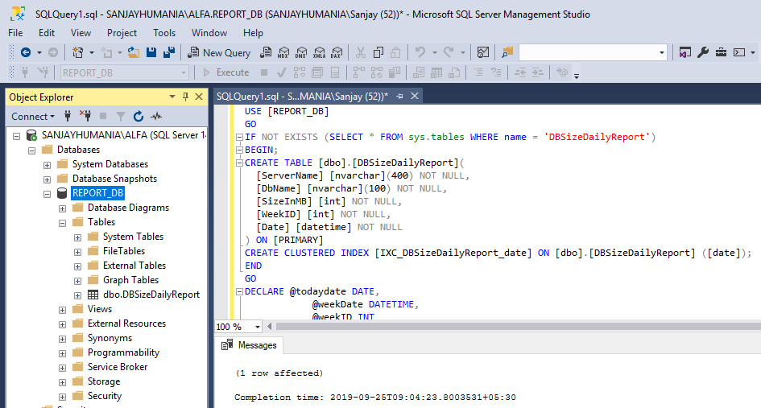
If we run select * from DBSizeDailyReport in the REPORT_DB database below result will be shown.
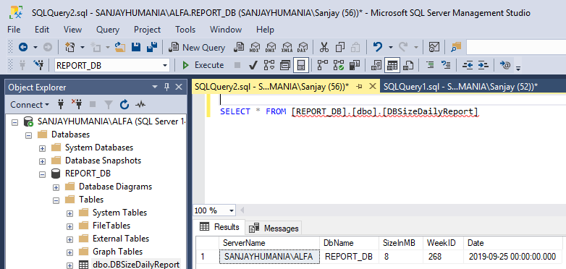

Job & schedule
Now to run the main script daily we may create a job & schedule the job.
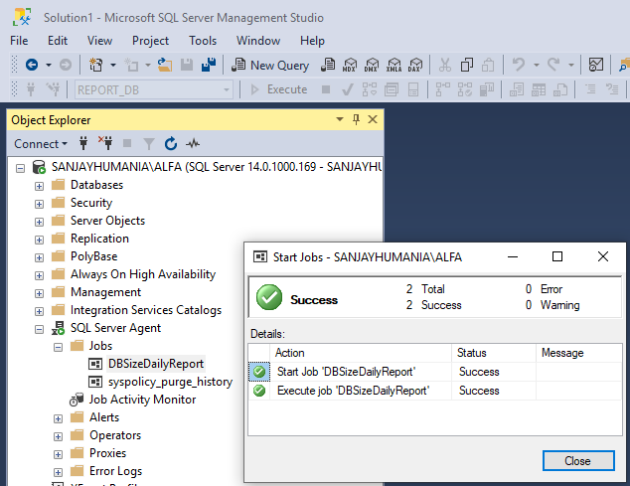
So, after a week or month if we check the table we will get the individual day database size.
Simply we can compare the date and calculate the database growth rate easily.

